Quincy Bock

MFADT: Major Studio 2

Final Project Paper Draft

4/15/13

1. Introduction

Science education is not just an issue of the classroom but of society. Our current society and economy are in great need of scientists, engineers, technologies, computer programmers and mathematicians. But our society and education systems are failing to foster the growth of new generations into these roles. Many young people who once were excited by exploration and experimentation are, as they age, scared away from the sciences because they think they are too hard, boring, not applicable to their lives, or nerdy. The result is a nation falling farther and farther behind in its ability to inspire and educate students in the sciences.[1] Science needs a makeover. Rather than force-feeding facts and figures to reluctant teens or imposing ever-stricter measures of standardization, we need to find more ways to celebrate science, ignite a spark of interest and engage students in learning. This can be done through applying ideas of systems thinking, good design and technologically enabled storytelling.

1. Background

As digital natives grow up, they require ever-more engaging and interactive means of holding their attention. The media does an excellent job of exploiting cutting edge technology, narrative and interaction to catch peoples’ attention and inspire them to action. There is no reason that science, with its many awe-inspiring wonders cannot do the same. However, doing so might require the involvement of industries and practices previously unknown to science education and a new focus on design – curriculum design, educational resource design or even just public relations design.

Two key factors are missing in the presentation of scientific material: application and excitement. As Sir Ken Robinson argues, the current educational system was designed to create productive contributors to society for a different time.[2] The intellect-loving atmosphere of the Enlightenment created a system for educating children to be successful in the age of the Industrial Revolution. We are not currently in the Industrial Revolution and students do not see the application of science education to their own lives or futures. It is not that this information has no bearing on them anymore, but that it is not presented in a way that seems personally exciting. For example, in a poll of 4,000 students between nine and fourteen years old, nearly half of the children “did not know that they would need a science background in order to pursue a career in plastic surgery.”[3] Something is clearly missing from the process of learning which could greatly contribute to the interest in and motivation to study science.

The second thing that is missing from science education culture is excitement. Science has a reputation for being boring and hard. There are excellent exceptions to this rule including fireworks, dissection and explosive chemical reactions; however, many students do not feel they are smart enough to approach these subjects and they do not have the motivation to try because they think the payoffs will be lackluster. The reality is quite the opposite. Students do have the intellect to learn difficult thing incrementally and the potential benefits of learning and experimenting are high. But science curricula do not foster this type of outlook. Contrastingly, video games (which teenagers love) do just this. Anyone who has played a good video game will tell you that they were not able to beat the final level when they were just starting to play. Instead, the video game delivers the tools to you and develops the skills in you that you need succeed at each point in the game. Video games do this in different forms, presenting you with information, challenges, puzzles or tools to help you progress at each stage.[4]

While gamification is one approach to education, I am not suggesting that middle school science classrooms must be completely revamped to become video games. Instead, I think that we can learn from the successes of games and recognize their place in the classroom. As Katie Salen points out, games, playful activities or interactives do not have “to be the holder of all content.”[5] Instead, like in games themselves, digital media, interactives or games can deliver just on part of information of an entire curriculum whether that be the inspiration to learn more, a visualization of systemic relationships or a place to practice one skill.

A great example of this type of supplemental material is the program Swimbots.[6] Swimbots does not teach an individual fact but it exposes users to the systemic relationships of genetics, traits, natural selection and evolution in an illustrative, exploratory and interactive way. Swimbots creates number of randomly generated “organisms” which have different traits including number of limbs, color, movement and joint type. These creatures are scattered around a virtual pool where they can do two things: eat or reproduce. The combination of random traits which they receive determine their success at accomplishing these two tasks. If the bots are not good at moving they will not be able to swim to food and will therefore die. If they are good at moving they will likely run into some food and therefore continue living. Likewise, the better any individual creature is at moving around the more likely it is to run into a potential partner and therefore pass on its genetic information in the form of an offspring. Bots that are not able to move will reproduce less.

By creating a few simple rules and some randomly generated variation, Swimbots beautifully plays out natural selection on a small scale. This program lets users see and experience the process of natural selection through the Swimbots and the “mini-dramas” that the program highlights. Because the virtual creatures that can move around the best are able to get food and reproduce their traits (including their ability to “swim”) are passed on to create more creatures like them. Over time the ability to swim is “selected” because it gives the bots that posses it a survival advantage over those who cannot move. The program allows users to follow good swimmers around, see others die, mate any two creatures or play with the genetic makeup of the creatures. It allows for experimentation and interaction which shows the system of natural selection at play without ever mentioning too much scientific terminology.

To this end, I began researching how I could create my own type of playful and inspiring science education supplement using digital media and interaction.

1. Research

I started my research process by surveying elementary, middle and high school science teachers across the country. By going through the USA Science and Engineering Festival’s Teacher Newsletter and by broadcasting on Facebook, I was able to receive many responses about from a broad range of educators teaching different subjects, different age groups and in different regions of the country. Although these different teachers taught students in every grade from kindergarten to 12th grade and taught very different subjects ranging from computer science to ecology, the responses showed clear trends that transcended age or subject. These results helped me narrow the focus.

I asked teachers a number of questions focused on the process of learning scientific material and the excitement, or lack thereof, that surrounded the subject matter. The individual responses were varied but the trends in the results were very telling. I asked teachers these questions and extrapolated these results:

1. What topic do you find hardest to teach?

- Teachers almost unfailingly responded that they found abstract or intangible ideas hardest to teach. These topics involved scientific subject matter that was either too big or to small to see or was just plain invisible (for example, forces like magnetism). There were also a number of teachers who admitted that the reason they found certain subjects hard to teach was because they did not understand them very well themselves.

1. What topic do your students find hardest to grasp?

- Unsurprisingly, many of the subjects that students had a hard time learning were the same topics that teachers had a hard time teaching. Although these were different from teacher to teacher, if an individual teacher struggled to come up with ways to convey a subject matter, students struggled to understand it. There were also some other reasons that teachers cited as contributing to a students difficulty in learning a topic: there was too much new terminology at once, they didn’t see the application to their life, it was too abstract.

1. What topic are you most excited to teach?

- In sharp contrast to the subjects that they found difficult to teach, the subjects that teachers were most excited to teach were those with exciting demonstrations, experimentation and concrete examples. Teachers also cited personal interesting a subject matter as a reason that they were excited to pass on this information to their students.

1. What topic do your students get most excited to learn about?

- Likewise, students were often most excited about subjects with a wow-factor. Anything physical that blew up or got messy was reported as very popular with students. Often these exciting demonstrations were related to the things their teachers were most passionate or excited about. Students were also reported to love going outside, performing experiments, learning about themselves and doing anything with interactive online media.

When extrapolating these conclusions from each question and reviewing the entire results of the survey together, a number of things stood out to me. The subject matter did not really matter that much. Some teachers loved teaching chemistry and their students found it easy to grasp. Other teachers, didn’t like chemistry very much and therefore found it hardest to teach. For teachers and students alike, the subjects that excited them most and were most inspiring were the easiest to understood. Having said this, there was a significant trend away from abstract ideas being the most exciting. While it was possible for hardcore biochemistry enthusiasts to bring ideas alive for their students, most teachers, like their students, struggled with abstract topics.

This realization helped me narrow the focus of my own project to address the gaps in science education. I decided to concentrate on an abstract subject matter that does not lend itself easily to physical demonstration or manifestation. Technology does deal with this type of thing very well because it can visualize and make tactile (in as much as a mouse or an iPad is tactile) and interactive unseen bits of data or ideas. Rather than supplanting an already perfectly good and exciting demonstration, exercise or activity that a teacher could implement, I decided to focus on one of the abstract ideas that many teachers find difficult to demonstrate to their students.

I also decided to broaden my audience to include not just students but teachers since so much of the ease of teachings seemed to stem from personal interest and excitement in a subject. By making a tool that is accessible to both students and teachers, I hope to provide the impetus, inspiration, and materials for stimulating excitement about abstract scientific subjects.

1. Process

To develop my idea, I created a number of prototypes to test different aspects of the final design and weigh them against audience and user reactions. The prototypes included an aesthetic/look and feel prototype, an interaction/participation prototype and an implementation prototype.

*a. Look and Feel*

The first of these was a look and feel prototype. As I mentioned previously there are many different science recourses available to teachers ranging from very simple physical tools like a toy which allows you to build structures with straws to extremely complex multiuser games or simulations which teach entire course loads. However, with many of these what I found was that because they were created by scientists and engineers and not designers, the aesthetic style was quite limited and practical - uninspiring. There were a few excellent exceptions to this rule but overall the best scientific tools were the worst aesthetically.

The major downfall of the best scientific simulations or interactions was that the aesthetic choices were arbitrary in the sense that the creators just picked whatever and used it as a placeholder for what they were trying to represent. An excellent example of this is the University of Colorado forces and motion science simulation.[7] In an effort to demonstrate the scientific principles they selected their visuals based on semantic meanings but neglected to consider the narrative of what they are trying to show.

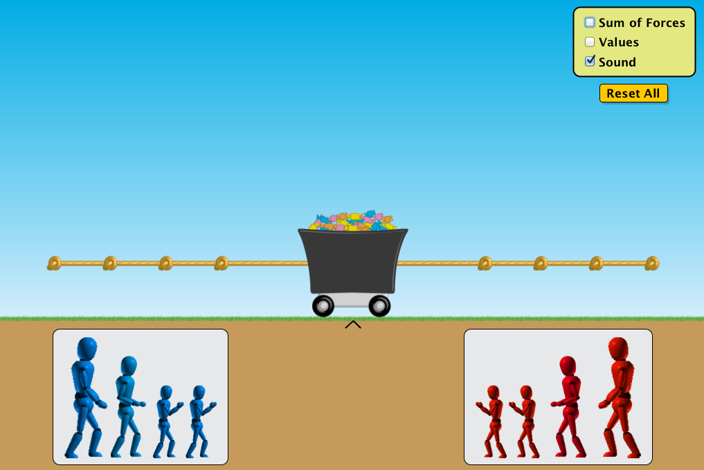

In this screenshot from the application you can see a tug of war scene. Weirdly colored figures represent people and forces. The size of these figures represents the strength of the force. They are pulling a mass which is represented by a coal wagon filled with colored candies which sits on top of the thinnest known layer of grass. This grass is above a solid brown rectangle which is the ground. A kind-of aesthetic narrative is clear here, but it entirely inconsistent and arbitrary. The figures do not encourage empathy in the user or inspire any sort of emotion. While a science tool does not have to (or even want to) be a story, in order to engage (sometimes reluctant) users it must inspire in some way if it hopes to be successful. After observing this, it became very apparent that in creating my own tool the aesthetic qualities must draw the user into a consistent overall feel.

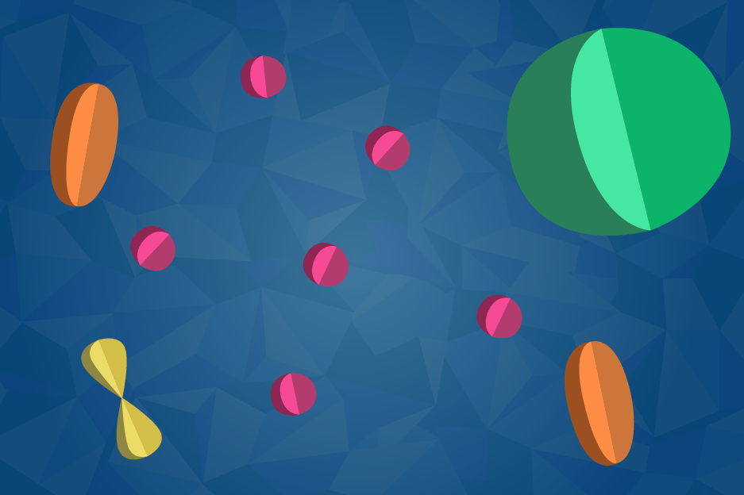

For my own look and feel prototype I created a color pallet and initial mock up of a potential style. I choose bright, saturated colors and a “cutout” style to imply three dimensionality while acknowledging the imprecise nature of representation. While these objects would only ever manifest on the screen I wanted to involve a little bit of physicality by playing with light and shadow. While this initial design is by no means the final solution it helped me articulate and explore the ways in which I could consistently apply a design strategy to create a cohesive look and feel. Reactions to this prototype were positive and allowed me to move forward to my first interaction prototype.

*b. Interaction*

To develop a narrative, I first had to decide what subject matter to focus on. In the look and feel prototype I approached the subject of molecular biology for a number of reasons. Firstly, in the teacher survey I conducted, molecular biology and biochemistry were two subjects frequently cited as being both difficult to teach and difficult to learn because the “objects” that you are dealing with in molecular biology are far too small to see and explaining their relationships is very abstract. In addition, I wanted to target a subject that is taught at the age that students generally begin to loose interest in science. My hope is that by igniting the imagination and making something that shows that science is fun and interesting, I can contribute to fostering a continued love of science.

Middle school is typically the age at which students begin to lose interest in science and mathematics. This is for a number of reasons. Many students think it is too hard or boring, but these ideas usually stem from the fact that they no longer see the relevance of these subjects to their own life or lose sight of the excitement and wonder in science.[8] I saw the same sentiments in the teacher survey. Because this is a nationwide issue it is clear that there is something in the curriculum which intersects with students at a certain age and creates disinterest rather than excitement. Part of the problem is probably just the age - twelve and thirteen year olds are just starting to be interested in developing their own social lives and going against the grain, but we need to find ways to reinvigorate interest, involvement and investment in these subjects. To do so I chose to target the middle school science curriculum subjects and of those focus on the more abstract topics that teachers and students struggle with. For this reason I decided to make an interactive tool about microbiology.

However, in creating a narrative around this subject I did not simply want to teach the terms and facts, but instead focus on the systems relationships and how disciplines interrelate and apply to our lives. In pursuit of this goal, I decided to make an online scrolling animation interaction which demonstrates the hierarchical and systemic relationship between the building blocks of life. For this prototype I created a storyboard showing how animations would move from atomic to molecular to cellular level creating tissues and organs and then organisms (humans). This initial storyboarded narrative was quite comprehensive including everything from how different elements are made to atomic bonds to types of molecules to organelles, types of cells, tissues and organs. The overarching idea was that the website would be a loop with the animation zooming out until you could see a star which supernovae-d creating all the elements seen in the first section of the webpage. You can see this storyboard here: <http://54.235.78.70/microbio/storyboard/#start>.

The feedback I received on this prototype was that it was just too much information. After reviewing the complexity of my plan I agree with this assessment. Suggestions included isolating the sheer amount of information included by making it more modular, lessen the informational complexity but add to the interactivity so that it is more than just scrolling and to create more game mechanics. While I do not want this to be an online game, I appreciated the sentiment of wanting more ways to interact with the material than just scrolling. Even if that interaction is just well timed reading, I worked to integrate more contextualization and motivation into the site as the animation and scrolling progress.

It was at this point in the process, after receiving feedback on the attention span of a thirteen year old girl, that I decided to reconsider my audience. My main audience which I am aiming at is a combination of middle school students and adults. Because so much of what influenced the success of learning and teaching was personal motivation and excitement, I want this tool/interaction to be exciting and inspiring to students and adults alike. This means having simple enough words for middle-schoolers to understand, but also complex enough ideas, distilled in simple elegant ways, for adults to appreciate and wonder at.

*c. Implementation*

I made an initial implementation prototype to address the ways in which I could build this online so that it would be accessible to as many people as possible. This site shows a very simple set of animated images: <http://54.235.78.70/microbio/implementation/2/>. I used this exercise to figure out how I would be able to control backgrounds, images, text and other html elements. Going forward I have integrated actual graphics and storyboard outlines but this experiment allowed to see how I could manipulate different portions of the page in an animation way.

*d. Interaction 2*

For my second interaction prototype I developed a new storyboard and very simply animated it so that a user could combine the experience of the narrative with the scrolling mechanic…

1. Project

…

1. Conclusion

…

1. References

…

1. <http://www.nytimes.com/2012/12/11/education/us-students-still-lag-globally-in-math-and-science-tests-show.html?_r=0>
2. <http://www.youtube.com/watch?v=zDZFcDGpL4U&feature=player_embedded>
3. <http://www.telegraph.co.uk/news/uknews/2700145/Children-losing-interest-in-science-through-their-education-report-claims.html>
4. <http://www.edutopia.org/digital-generation-katie-salen-video>
5. <http://www.edutopia.org/digital-generation-katie-salen-video>
6. <http://www.swimbots.com/>
7. http://phet.colorado.edu/en/simulation/forces-and-motion-basics
8. http://www.telegraph.co.uk/news/uknews/2700145/Children-losing-interest-in-science-through-their-education-report-claims.html